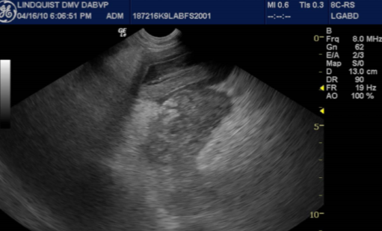
Figure 3: Example of pancreatitis affecting the right limb of the pancreas (Group 2): Hypoechoic edematous pancreatic parenchyma (middle arrow) and hyperechoic ill-defined surrounding fat (small thick arrow) consistent with saponification and inflamed mesentery. The upper descending duodenum in the near field is mildly edematous and adjacent to the pancreatic inflammation (long thin arrow). Image courtesy of Eric Lindquist Sonopath, Sparta, NJ, USA.

